|  |  |  |  |  |  |  |
| --- | --- | --- | --- | --- | --- | --- |
|  | | | | | | |
| **In** | **[18]:** | Data Visualization II  Use the inbuilt dataset 'titanic' as used in the above problem. Plot a box plot for distribution of age with respect to each gender along with the information about whether they survived or not. (Column names : 'sex' and 'age') Write observations on the inference from the above statistics.  **import numpy as np import pandas as pd**  **import matplotlib.pyplot as plt import seaborn as sns**  **train = pd.read_csv("Titanic.csv")**  **train.head(10)**  PassengerId Survived Pclass Name Sex Age SibSp Parch Ticket Fare Cabin Embarked | | | | |
| **In** | **[19]:** |
| **In** | **[20]:** |
| **Out** | **[20]:** |
|  |  | Braund,  0 1 0 3 Mr. Owen male 22.0 1 0  Harris  Cumings, Mrs. John  1 2 1 1 Bradley female 38.0 1 0  (Florence  Briggs Th...  Heikkinen,  2 3 1 3 Miss. female 26.0 0 0  Laina  Futrelle, Mrs.   1. 4 1 1 Jacques female 35.0 1 0   Heath  (Lily May Peel)  Allen, Mr.   1. 5 0 3 William male 35.0 0 0   Henry  Moran,   1. 6 0 3 Mr. male NaN 0 0   James  McCarthy,  6 7 0 1 Mr. male 54.0 0 0  Timothy J  Palsson,   1. 8 0 3 Master. male 2.0 3 1   Gosta  Leonard  Johnson, Mrs.   1. 9 1 3 Oscar W female 27.0 0 2   (Elisabeth  Vilhelmina Berg) | A/5 21171 | 7.2500 | NaN | S |
| PC 17599 | 71.2833 | C85 | C |
| STON/O2. 3101282 | 7.9250 | NaN | S |
| 113803 | 53.1000 | C123 | S |
| 373450 | 8.0500 | NaN | S |
| 330877 | 8.4583 | NaN | Q |
| 17463 | 51.8625 | E46 | S |
| 349909 | 21.0750 | NaN | S |
| 347742 | 11.1333 | NaN | S |
|  |  | Nasser, |  |  |  |  |
|  |  | Mrs. |  |  |  |  |
|  |  | 9 10 1 2 Nicholas female 14.0 1 0 | 237736 | 30.0708 | NaN | C |
|  |  | (Adele |  |  |  |  |
|  |  | Achem) |  |  |  |  |
| **In** | **[21]:** | **train.drop(["PassengerId",'Ticket'],axis = 1,inplace = True)** |  |  |  |  |

**In [22]:**

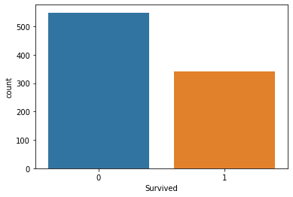

train.info()

**<class 'pandas.core.frame.DataFrame'> RangeIndex: 891 entries, 0 to 890 Data columns (total 10 columns):**

**# Column Non-Null Count Dtype**

|  |  |  |  |  |  |  |
| --- | --- | --- | --- | --- | --- | --- |
| **0** |  | **Survived** | **891** | **non-null** |  | **int64** |
| **1** |  | **Pclass** | **891** | **non-null** |  | **int64** |
| **2** |  | **Name** | **891** | **non-null** |  | **object** |
| **3** |  | **Sex** | **891** | **non-null** |  | **object** |
| **4** |  | **Age** | **714** | **non-null** |  | **float64** |
| **5** |  | **SibSp** | **891** | **non-null** |  | **int64** |
| **6** |  | **Parch** | **891** | **non-null** |  | **int64** |
| **7** |  | **Fare** | **891** | **non-null** |  | **float64** |
| **8** |  | **Cabin** | **204** | **non-null** |  | **object** |
| **9** |  | **Embarked** | **889** | **non-null** |  | **object** |

**dtypes: float64(2), int64(4), object(4) memory usage: 69.7+ KB**

**In [23]:**

train.describe()

**Out [23]:**

|  |  |  |  |  |  |  |
| --- | --- | --- | --- | --- | --- | --- |
|  | Survived | Pclass | Age | SibSp | Parch | Fare |
| count | 891.000000 | 891.000000 | 714.000000 | 891.000000 | 891.000000 | 891.000000 |
| mean | 0.383838 | 2.308642 | 29.699118 | 0.523008 | 0.381594 | 32.204208 |
| std | 0.486592 | 0.836071 | 14.526497 | 1.102743 | 0.806057 | 49.693429 |
| min | 0.000000 | 1.000000 | 0.420000 | 0.000000 | 0.000000 | 0.000000 |
| 25% | 0.000000 | 2.000000 | 20.125000 | 0.000000 | 0.000000 | 7.910400 |
| 50% | 0.000000 | 3.000000 | 28.000000 | 0.000000 | 0.000000 | 14.454200 |
| 75% | 1.000000 | 3.000000 | 38.000000 | 1.000000 | 0.000000 | 31.000000 |
| max | 1.000000 | 3.000000 | 80.000000 | 8.000000 | 6.000000 | 512.329200 |

**In [24]:**

sns.countplot(x='Survived', data=train);

**In [25]:**

train.groupby(['Survived','Sex'])['Survived'].count()

**Out [25]: Survived Sex**

|  |  |  |
| --- | --- | --- |
| **0** | **female** | **81** |
|  | **male** | **468** |
| **1** | **female** | **233** |
|  | **male** | **109** |

**Name: Survived, dtype: int64**

**In [40]:**

train[train['Sex'] == 'male'].Survived.groupby(train.Survived).count().plot(kind='pie', plt.axis('equal')

plt.legend(["Perished","Survived"]) plt.title("Male survival rate") plt.show()

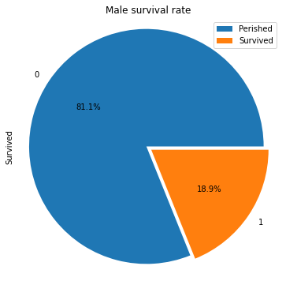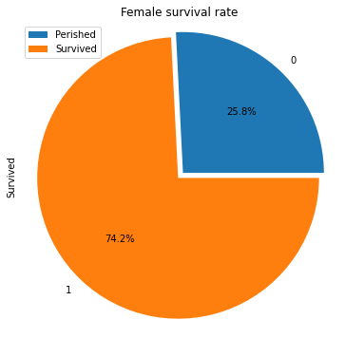

**In [ ]:**

**In [27]:**

train[train['Sex'] == 'female'].Survived.groupby(train.Survived).count().plot(kind='pie' plt.axis('equal')

plt.title("Female survival rate") plt.legend(["Perished","Survived"]) plt.show()

**In [ ]:**

**In [28]:**

pd.crosstab(train.Pclass, train.Survived, margins=True)

**Out [28]:**

|  |  |  |  |
| --- | --- | --- | --- |
| Survived  Pclass | 0 | 1 | All |
| 1 | 80 | 136 | 216 |
| 2 | 97 | 87 | 184 |
| 3 | 372 | 119 | 491 |
| All | 549 | 342 | 891 |

**In [29]:**

train[train['Pclass'] == 1].Survived.groupby(train.Survived).count().plot(kind='pie', fi plt.axis('equal')

plt.legend(["Perished","Survived"]) plt.title("First class survival rate") plt.show()

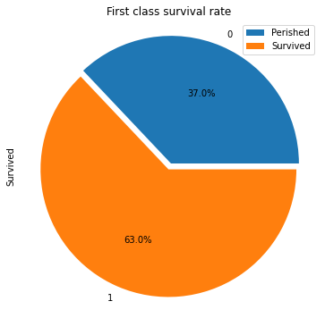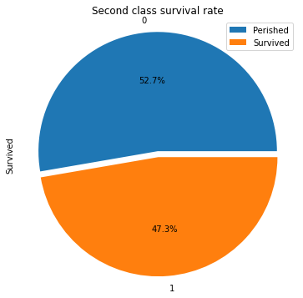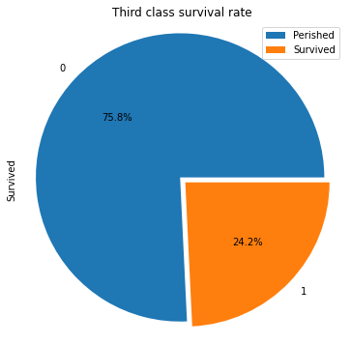

**In [30]:**

train[train['Pclass'] == 2].Survived.groupby(train.Survived).count().plot(kind='pie', fi plt.axis('equal')

plt.legend(["Perished","Survived"])

plt.title("Second class survival rate") plt.show()

**In [31]:**

train[train['Pclass'] == 3].Survived.groupby(train.Survived).count().plot(kind='pie', fi plt.axis('equal')

plt.legend(["Perished","Survived"]) plt.title("Third class survival rate") plt.show()

**In [32]:**

**Out [32]:**

**In [33]:**

sns.barplot('Pclass','Survived',hue='Sex', data=train)

pd.crosstab([train.Sex, train.Survived], train.Pclass, margins=True)

|  |  |  |  |  |  |
| --- | --- | --- | --- | --- | --- |
| Pclass 1 | | | 2 | 3 | All |
| Sex | Survived |  |  |  |  |
| female | 0 | 3 | 6 | 72 | 81 |
|  | 1 | 91 | 70 | 72 | 233 |
| male | 0 | 77 | 91 | 300 | 468 |
|  | 1 | 45 | 17 | 47 | 109 |
| All |  | 216 | 184 | 491 | 891 |

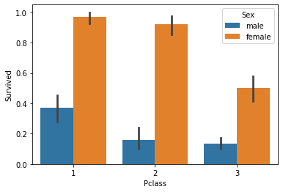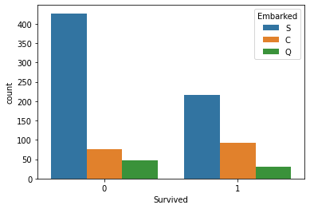

**/home/ihack-pc/.local/lib/python3.8/site-packages/seaborn/_decorators.py:36: FutureWarning: Pass the following variables as keyword args: x, y. From version 0.12, the only valid positional argument will be**

**`data`, and passing other arguments without an explicit keyword will result in an error or misinterpretation.**

**warnings.warn(**

**Out [33]: <matplotlib.axes._subplots.AxesSubplot at 0x7f78feefa460>**

**In [34]:**

sns.countplot(x='Survived', data=train,hue = 'Embarked');

**In [35]:**

pd.crosstab([train.Sex, train.Survived], [train.SibSp, train.Pclass], margins=True)

**Out [35]:**

|  |  |  |  |  |  |  |  |  |  |  |  |  |  |  |  |  |  |
| --- | --- | --- | --- | --- | --- | --- | --- | --- | --- | --- | --- | --- | --- | --- | --- | --- | --- |
|  | SibSp | 0 |  |  | 1 |  |  | 2 |  |  | 3 |  |  | 4 | 5 | 8 | All |
| Pclass | 1 | 2 | 3 | 1 | 2 | 3 | 1 | 2 | 3 | 1 | 2 | 3 | 3 | 3 | 3 |  |
| Sex | Survived |  |  |  |  |  |  |  |  |  |  |  |  |  |  |  |  |
| female | 0 | 1 | 3 | 33 | 2 | 3 | 21 | 0 | 0 | 3 | 0 | 0 | 7 | 4 | 1 | 3 | 81 |
|  | 1 | 48 | 41 | 48 | 38 | 25 | 17 | 3 | 3 | 4 | 2 | 1 | 1 | 2 | 0 | 0 | 233 |
| male | 0 | 59 | 67 | 235 | 16 | 20 | 35 | 1 | 4 | 7 | 1 | 0 | 4 | 11 | 4 | 4 | 468 |
|  | 1 | 29 | 9 | 35 | 15 | 7 | 10 | 1 | 1 | 1 | 0 | 0 | 0 | 1 | 0 | 0 | 109 |
| All |  | 137 | 120 | 351 | 71 | 55 | 83 | 5 | 8 | 15 | 3 | 1 | 12 | 18 | 5 | 7 | 891 |

**In [36]:**

pd.crosstab([train.Sex, train.Survived], [train.Parch, train.Pclass], margins=True)

**Out [36]:**

|  |  |  |  |  |  |  |  |  |  |  |  |  |  |  |  |  |  |
| --- | --- | --- | --- | --- | --- | --- | --- | --- | --- | --- | --- | --- | --- | --- | --- | --- | --- |
|  | Parch | 0 |  |  | 1 |  |  | 2 |  |  | 3 |  | 4 |  | 5 | 6 | All |
| Pclass | 1 | 2 | 3 | 1 | 2 | 3 | 1 | 2 | 3 | 2 | 3 | 1 | 3 | 3 | 3 |  |
| Sex | Survived |  |  |  |  |  |  |  |  |  |  |  |  |  |  |  |  |
| female | 0 | 1 | 5 | 35 | 0 | 1 | 13 | 2 | 0 | 17 | 0 | 1 | 0 | 2 | 3 | 1 | 81 |
|  | 1 | 63 | 40 | 50 | 17 | 17 | 12 | 11 | 11 | 8 | 2 | 1 | 0 | 0 | 1 | 0 | 233 |
| male | 0 | 63 | 81 | 260 | 10 | 7 | 22 | 3 | 3 | 15 | 0 | 1 | 1 | 1 | 1 | 0 | 468 |
|  | 1 | 36 | 8 | 36 | 4 | 7 | 8 | 5 | 2 | 3 | 0 | 0 | 0 | 0 | 0 | 0 | 109 |
| All |  | 163 | 134 | 381 | 31 | 32 | 55 | 21 | 16 | 43 | 2 | 3 | 1 | 3 | 5 | 1 | 891 |

# The above crosstab indicates 2 things:

1. Most of the passerenges didn't had parents onboard and the majority had atmost 1 parent onboard

# Not much of priority was given to the passengers who had parents onboard in the rescue operation

**In [26]:**

train.corr()

**Out [26]:**

|  |  |  |  |  |  |  |
| --- | --- | --- | --- | --- | --- | --- |
|  | Survived | Pclass | Age | SibSp | Parch | Fare |
| Survived | 1.000000 | -0.338481 | -0.077221 | -0.035322 | 0.081629 | 0.257307 |
| Pclass | -0.338481 | 1.000000 | -0.369226 | 0.083081 | 0.018443 | -0.549500 |
| Age | -0.077221 | -0.369226 | 1.000000 | -0.308247 | -0.189119 | 0.096067 |
| SibSp | -0.035322 | 0.083081 | -0.308247 | 1.000000 | 0.414838 | 0.159651 |
| Parch | 0.081629 | 0.018443 | -0.189119 | 0.414838 | 1.000000 | 0.216225 |
| Fare | 0.257307 | -0.549500 | 0.096067 | 0.159651 | 0.216225 | 1.000000 |

**In [27]:**

**Out [27]:**

train.head(10)

Survived Pclass Name Sex Age SibSp Parch Fare Cabin Embarked

0 0 3 Braund, Mr. Owen Harris male 22.0 1 0 7.2500 NaN S

# 1 1 1 Cumings, Mrs. John Bradley

(Florence Briggs Th...

# female 38.0 1 0 71.2833 C85 C

(Elisabeth Vilhelmina Berg) Achem)

sns.barplot(y = "Age",x = "Survived",data = train)

|  |  |  |  |  |  |  |  |  |  |  |
| --- | --- | --- | --- | --- | --- | --- | --- | --- | --- | --- |
| 2 | 1 | 3 | Heikkinen, Miss. Laina | female | 26.0 | 0 | 0 | 7.9250 | NaN | S |
| 3 | 1 | 1 | Futrelle, Mrs. Jacques Heath | female | 35.0 | 1 | 0 | 53.1000 | C123 | S |
|  | |  | (Lily May Peel) |  |  |  |  |  |  |  |
| 4 0 | | 3 | Allen, Mr. William Henry | male | 35.0 | 0 | 0 | 8.0500 | NaN | S |
| 5 0 | | 3 | Moran, Mr. James | male | NaN | 0 | 0 | 8.4583 | NaN | Q |
| 6 0 | | 1 | McCarthy, Mr. Timothy J | male | 54.0 | 0 | 0 | 51.8625 | E46 | S |
| 7 0 | | 3 | Palsson, Master. Gosta Leonard | male | 2.0 | 3 | 1 | 21.0750 | NaN | S |
| 8 1 3 Johnson, Mrs. Oscar W female | | | | | 27.0 | 0 | 2 | 11.1333 | NaN | S |
| 9 1 2 Nasser, Mrs. Nicholas (Adele female | | | | | 14.0 | 1 | 0 | 30.0708 | NaN | C |

**In [41]:**

**Out [41]: <matplotlib.axes._subplots.AxesSubplot at 0x7f78fefa3a90>**

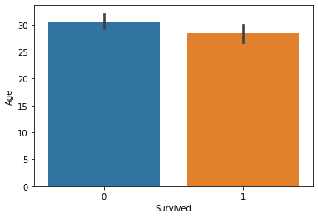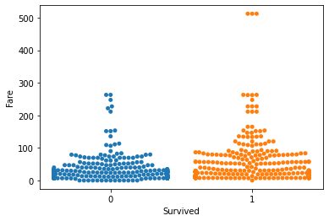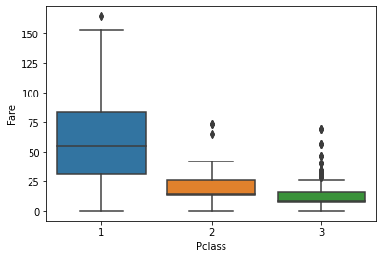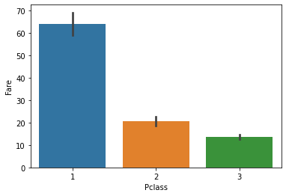

**In [29]:**

sns.swarmplot(x='Survived', y='Fare', data=train)

**/home/ihack-pc/.local/lib/python3.8/site-packages/seaborn/categorical.py:1296: UserWarning: 72.3% of the points cannot be placed; you may want to decrease the size of the markers or use stripplot.**

**warnings.warn(msg, UserWarning)**

**/home/ihack-pc/.local/lib/python3.8/site-packages/seaborn/categorical.py:1296: UserWarning: 46.5% of the points cannot be placed; you may want to decrease the size of the markers or use stripplot.**

**warnings.warn(msg, UserWarning)**

**In [30]:**

sns.boxplot(y = "Fare",x = "Pclass",data = train[train["Fare"] < 200])

**Out [30]: <matplotlib.axes._subplots.AxesSubplot at 0x7f7a48347df0>**

**In [31]:**

sns.barplot(y = "Fare",x = "Pclass",data = train[train["Fare"] < 200])

**Out [31]: <matplotlib.axes._subplots.AxesSubplot at 0x7f7a48347850>**

|  |  |  |  |  |  |  |
| --- | --- | --- | --- | --- | --- | --- |
| **In [32]:** | **sns.pairplot(train.drop("Name",axis = 1).dropna(),hue = "Survived")** | | | | |  |
| **Out [32]: <seaborn.axisgrid.PairGrid at 0x7f7a483c0430>**  **In [33]: train.groupby('Survived').describe()['Age']**  **Out [33]:** count mean std min 25% 50% 75% max Survived  0 424.0 30.626179 14.172110 1.00 21.0 28.0 39.0 74.0  1 290.0 28.343690 14.950952 0.42 19.0 28.0 36.0 80.0  **In [34]: train.head(5)**  **Out [34]:** Survived Pclass Name Sex Age SibSp   1. 0 3 Braund, Mr. Owen Harris male 22.0 1 2. 1 1 Cumings, Mrs. John Bradley female 38.0 1   (Florence Briggs Th...   1. 1 3 Heikkinen, Miss. Laina female 26.0 0 2. 1 1 Futrelle, Mrs. Jacques Heath (Lily female 35.0 1   May Peel)   1. 0 3 Allen, Mr. William Henry male 35.0 0 | |  |  |  |  |  |
| Parch | Fare | Cabin | Embarked |
| 0 | 7.2500 | NaN | S |
| 0 | 71.2833 | C85 | C |
| 0 | 7.9250 | NaN | S |
| 0 | 53.1000 | C123 | S |
| 0 | 8.0500 | NaN | S |
| **In [35]:** | **def extract(x):**  **temp = x.split(" ") if "Mr." in temp:** | | | | |  |

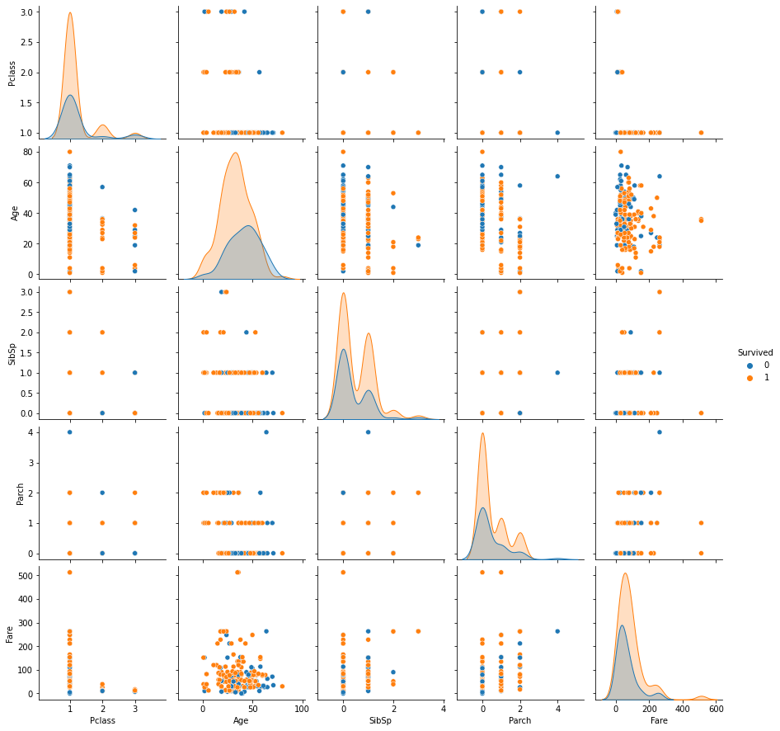

|  |  |  |  |  |
| --- | --- | --- | --- | --- |
|  | **return "Mr"**  **elif "Mrs." in temp: return "Mrs"**  **elif "Miss." in temp:**  **return "Miss"**  **elif "Master." in temp: return "Master"**  **elif "Dr." in temp:**  **return "Dr" else:**  **return None** | | |  |
| **In [36]: train["Category"] = train["Name"].apply(extract)**  **In [37]: train.head()**  **Out [37]:** Survived Pclass Name Sex Age SibSp Parch Fare Cabin   1. 0 3 Braund, Mr. Owen male 22.0 1 0 7.2500 NaN Harris   Cumings, Mrs. John   1. 1 1 Bradley (Florence female 38.0 1 0 71.2833 C85 Briggs Th... 2. 1 3 Heikkinen, Miss. female 26.0 0 0 7.9250 NaN Laina 3. 1 1 Futrelle, Mrs. Jacques female 35.0 1 0 53.1000 C123 Heath (Lily May Peel) 4. 0 3 Allen, Mr. William male 35.0 0 0 8.0500 NaN Henry   **In [38]: train["Category"].unique()**  **Out [38]: array(['Mr', 'Mrs', 'Miss', 'Master', None, 'Dr'], dtype=object)**  **In [39]: print("Mr." , np.mean(train[train["Category"] == "Mr"]["Age"]))**  **print("Mrs." , np.mean(train[train["Category"] == "Mrs"]["Age"]))**  **print("Miss." , np.mean(train[train["Category"] == "Miss"]["Age"]))**  **print("Master." , np.mean(train[train["Category"] == "Master"]["Age"]))**  **print("Dr." , np.mean(train[train["Category"] == "Dr"]["Age"]))**  **Mr. 32.368090452261306**  **Mrs. 35.898148148148145**  **Miss. 21.773972602739725**  **Master. 4.574166666666667**  **Dr. 42.0** | | Embarked S  C  S S S | Category Mr  Mrs  Miss Mrs Mr |  |